DASAR CSS
EXTERNAL_STYLE
INTERNAL_STYLE
INLINE_STYLE
SELECTOR

MARGIN

PADDING

BACKGROUND_WARNA1

BACKGROUND_WARNA2
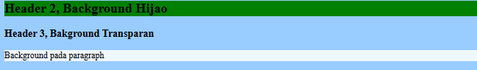
BACKGROUND1

BACKGROUND2
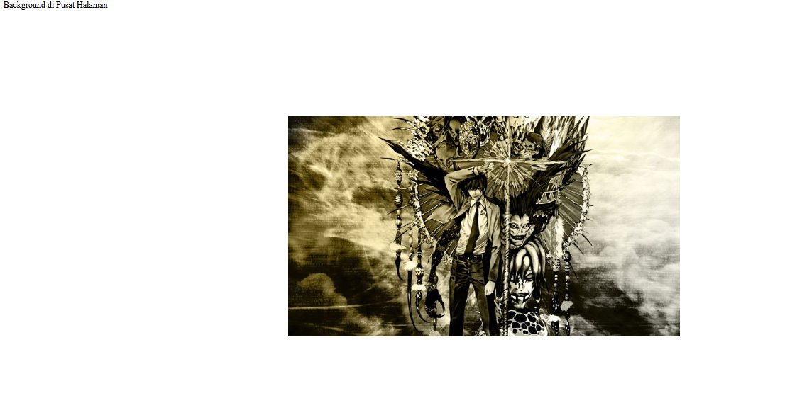
FORMAT_TEXT
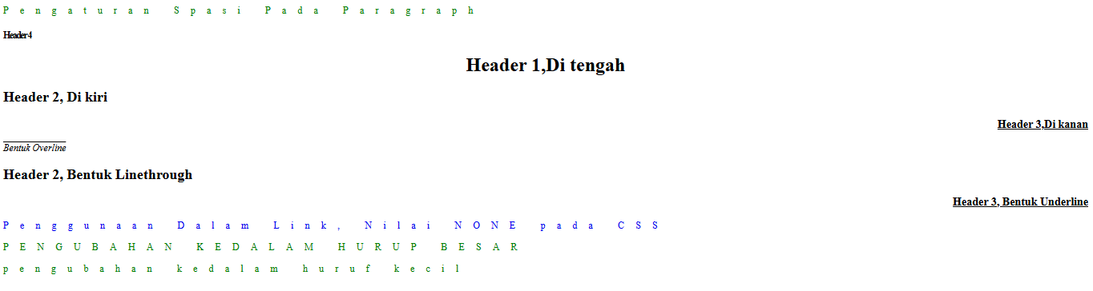
FONT
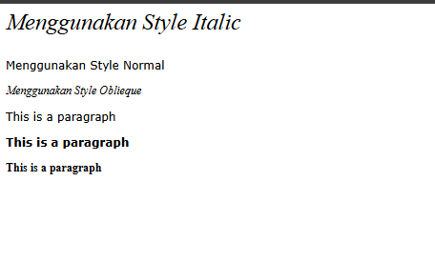
PADDING_TABEL
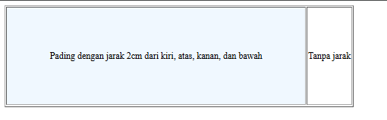
TABEL
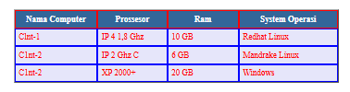

PROPERTY SELECTOR
TOMBOL_ANIMASI

TOMBOL_TABEL
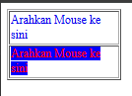
TOMBOL VISUAL


